**Architect’s Portfolio Engine: Global Multi-Asset Model 3.0 (“GMAM 3.0”)**

*Gain a Methodological Edge with iCapital’s GMAM 3.0*

**Intro**

As clients expect increasingly sophisticated portfolio analytics, advisors, researchers, and CIOs demand institutional quality analytical capabilities to gain an edge in their investment process. For multi-asset portfolios that include alternatives, there is an industry-wide need to provide in-depth analysis of an asset’s drivers of risk and return. Traditional holdings-based analyses provide valuable input in the decision-making process, but such analysis is often coarse and incomplete. While assets within traditional asset classes often move together, such groupings obfuscate unintended risks specific to investors’ portfolio holdings or strategies. For example:

* The equity component of a multi-asset portfolio may realize negative returns following rate increases.
* A high yield fixed income portfolio may perform poorly when equity markets drop, particularly when the market decline corresponds to economic fundamentals that would impact the underlying firms’ likelihood of servicing their debt.
* A hedge fund’s net dollar exposure may fluctuate substantially through time indicating varying levels of exposure to systematic risk.

Insightful portfolio analytics uncover portfolio risks, both at the construction stage and during ongoing maintenance. Factor modeling provides a convenient and scientifically well-regarded framework for determining systematic risk. The development of a scientifically rigorous estimation strategy that reflects the underlying economics of the analyzed assets is essential to accessing the benefits of factor models.

In this paper, we summarize the fundamental and differentiating components of Architect and its engine, GMAM 3.0. This methodology, while relying on well-established traditional academic research, uses modern quantitative techniques drawing from both established and recent research in economics and statistics. Compared to traditional models, GMAM 3.0 better tackles challenges associated with alternative strategies such as short track records.

**Motivation: Private Capital Performance Reporting**

The process by which private capital reports performance sets the asset class apart from both traditional assets and hedge funds. Managers report the returns of their private capital funds usually on a quarterly basis. Because private capital assets are rarely traded, the manager must estimate their value, a complex and resource intensive process, which may also rely on private company financial reporting or private asset appraisals. This effectively delays the observed effect of economic factors and smooths returns. In other words, while economic factors can affect the valuation of these assets, private capital’s returns appear smoothed due to delays in the valuation. From the perspective of investors, on a quarterly basis the manager provides an estimate of the value of the portfolio. The valuation combines a weighted average of past true (desmoothed) returns with a small amount additional idiosyncratic variance.

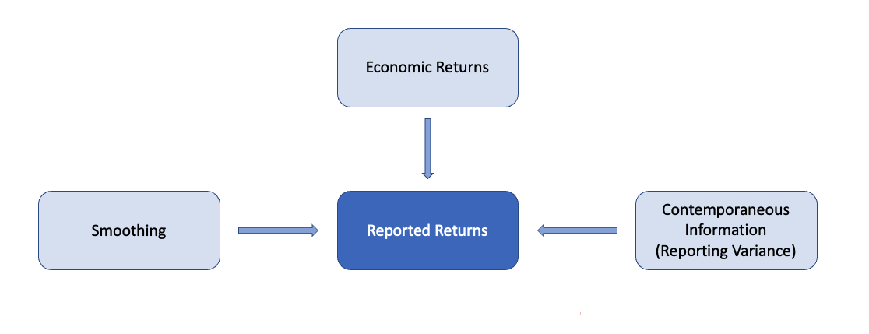

An investor that wishes to know the value of their portfolio must estimate the economic (true/desmoothed) returns of their private capital assets. The desmoothed returns have systematic drivers in addition to idiosyncratic variation. The below explains how GMAM 3.0 helps investors understand the systematic drivers of portfolio risk.

**Model Overview**

GMAM 3.0 is a probabilistic regression model. Using simulation methods, it estimates how fund returns co-move with a parsimonious set of factors, both in magnitude and timing. The model powers analytics to help clients understand not only the expected performance but also its credible range.

Two key aspects of the model differentiate with alternatives. First, GMAM 3.0 models the process by which private capital funds aggregate and report returns Components of returns include systematic drivers (factor returns), idiosyncratic variance, and delays in reporting. For example, given a spike in oil prices, the model predicts both the magnitude of the impact on reported returns as well as the time horizon over which the movement will manifest.

A set of observable factor-mimicking portfolios ("factors") proxy for the systematic drivers. The factors correspond to exposures such as equity and credit exposures. GMAM 3.0 uses an asset’s exposure to these factors along with the factor returns to estimate the entire systematic portion of the economic returns. The economic returns are equal to the estimate of the returns corresponding to variation of the factors plus residual variation, which may include both idiosyncratic and unobserved systematic variation.

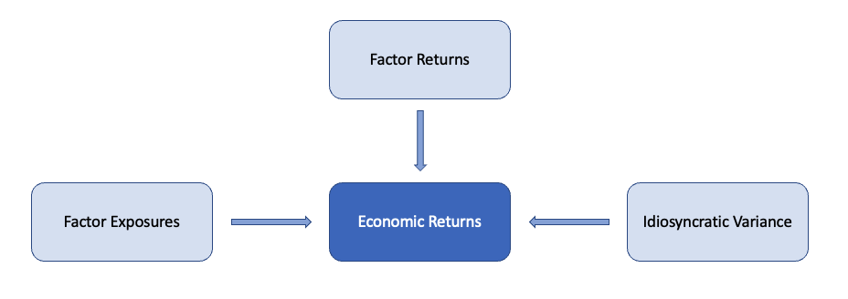

Second, GMAM 3.0’s performance estimation is not limited by the fund’s track record. The model econometrically blends performance expectations with realized returns. GMAM 3.0 may weigh the expectations of research analysts or the performance of a manager’s past funds against realized performance of the current fund. By providing a framework through which outside information enters the analytics, the model overcomes the deleterious effects of smoothed and limited track records.

**Key outputs of the model:**

GMAM 3.0 estimates:

* De-smoothed returns – As previously described, infrequent valuation smooths private capital fund track records. GMAM 3.0 accounts for the inherent delay between a change in an asset’s value and when this change is reported to investors. Part of this process includes estimation of the assets desmoothed returns. Factor exposures – GMAM 3.0 leverages a framework of 13 factors that capture equity, fixed income, and alts exposures.. The model regresses the reported returns of assets against these 14 factors to estimate the sensitivity of an asset to the different factors, which enables users to see the driving forces behind the assets.
* Factor based returns – Using the computed factor exposures and the actual performance history of those factors, the model estimates the performance of the factor-based proxy portfolio in a historical period.
* Credible Intervals – As a probabilistic model, GMAM 3.0 estimates not only the most likely value of each parameter but also the parameter’s full probability distribution.

**Key Pillars of the Model**

Pillar 1: Use a Multi-Factor Model

A small number of economic and technical forces drive the returns of both public and private assets. Factor mimicking portfolios (“factors”) proxy for these drivers. An effective estimation methodology estimates the covariation between an asset and each factor.

Pillar 2: Economic Returns Matter

As mentioned, infrequent valuation and reporting leads to smoothing of private capital fund track records. GMAM 3.0 uses factor movements to both estimate de-smoothed returns for the reporting period and predict smoothed and de-smoothed returns for longer historical periods. Estimation of the de-smoothed returns leads to more insightful estimates on the same underlying reported data. By effectively estimating the length of time that a particular factor movement manifests in the reported returns, GMAM 3.0 separates the return reporting process from the underlying changes in the portfolio’s market value.

Pillar 3: Outside information is important

The information available about any fund extends beyond the fund’s track record. Bayes theorem provides a rigorous mechanism to account for outside information. GMAM 3.0 weighs outside information, encoded as priors, against an asset’s historical performance.

As intuition, consider providing a 95% confidence interval around average annual temperature of a US city selected at random. Without knowing the name of the city, you might begin with a very wide range of temperatures. After receiving one month of daily data, you might update your estimate and potentially narrow your range. GMAM 3.0 updates its predictions in a similar fashion.

**Estimating the model**

The parameters (factor exposures and smoothing) are estimated in accordance with Bayes rule:  
  
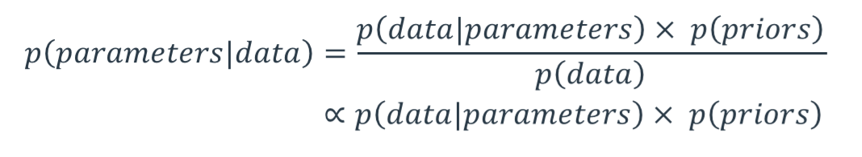

Bayes' rule is a fundamental principle in probability theory that describes how to update our beliefs about an event based on new information. It states that the probability of an event given some evidence is proportional to the probability of that evidence given the event multiplied by the prior probability of the event. In GMAM 3.0, priors may include subjective beliefs formed from fund due diligence about performance.